SECTION A – STRATEGIC PLANNING, ARCHITECTURE & LOGICAL DESIGN

1. Project Parameters & Visual Direction
A. Core Vision and Milestones
I built the Quick Koffiee web application to act as a seamless digital bridge for the busy campus community at Botswana Accountancy College (BAC). Between tight lecture schedules, assignments, and meetings, students and staff face long queues at campus food spaces. Instead of deploying an overcomplicated, slow-loading corporate application, this project focuses on a lightweight, mobile-first lookbook and interactive pre-ordering hub. It bridges the gap between our busy schedules and a quick caffeine fix, allowing users to browse daily options and pre-format their orders while walking across campus.
From the start, the development kept its eyes on a few key milestones:
i. Clean, Semantic Layout: Grouping real daily coffee products into responsive sections so items display clearly on small smartphone viewports without layout distractions.
ii. Frictionless Campus Ordering: Building an integrated client-side cart system that calculates exact totals locally and formats an instant checkout string routed straight to a campus vendor via a WhatsApp API link shortcut.
iii. Targeted Social Proof: Dedicated reviews section capturing real student and lecturer feedback to establish brand trust within the campus network.
iv. Compliance with Strict Technical Limits: Writing lightweight, modern code that relies entirely on structural semantic layout elements, completely avoiding empty container chains (<div> elements) to fulfill code compliance rubrics.
B. Defining the Target Audience
i. Who they are: The primary target market consists of BAC students (aged 18–25) and professional academic/support staff (aged 26–55). They are fast-paced, highly tech-literate, and frequently consume caffeine to get through long study hours and lectures.
ii. How they browse: This audience depends heavily on mobile browsing during brief intervals between classes. They expect instant load times, thumb-friendly touch targets, and layouts that do not break or require horizontal scrolling when held in a single-handed upward (portrait) orientation. If text squishes or buttons misalign, bounce rates increase immediately.
C. Website Typology
At its core, Quick Koffiee operates as an interactive product catalog and decentralized mobile-ordering hub. By prioritizing performance, it skips heavy database-driven account registration forms and server-side payment gateways. Instead, it utilizes client-side web capabilities combined with native Bootstrap UI components to run as an agile, lightweight digital lookbook.
2. Structural Mapping & Information Architecture
To guarantee an effortless user journey, the web application incorporates a flat navigation architecture. From any given view, a visitor can transition directly to another section with a single tap, eliminating the barrier of deep drop-down mobile menus.
- Home Screen (index.html): Our digital front door. It welcomes the campus with the brand identity, an immediate value-driven motto, and a highlight layout of daily coffee specials.
- Our Story (about.html): The narrative heart of the brand. It establishes community connection by laying out the brand’s mission of supplying freshly roasted artisan coffee to the BAC community.
- The Menu (menu.html): The core product catalog showcasing individual drinks (Espresso, Brew, Iced Coffee) priced explicitly in Botswana Pula (BWP), featuring dedicated operational order triggers.
- Community Feedback (reviews.html): Our social validation panel, displaying text reviews and high-contrast star ratings from local campus peers.
- Your Cart (cart.html): The functional checkout interface reads collected items from browser memory, tallies accurate pricing subtotals, and hosts prominent transactional triggers.
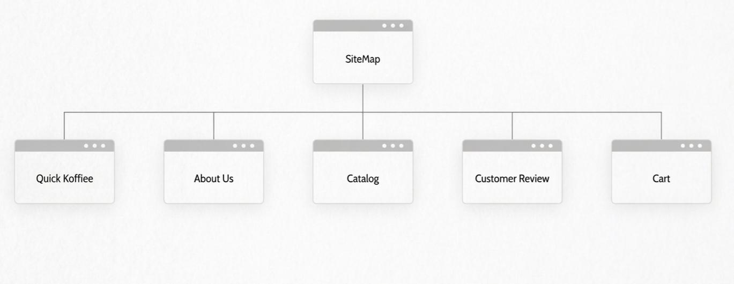
This is the sitemap to show the layout of the website.
3. Wireframing & Page Blueprinting
To maintain consistency and user familiarity, every page relies on a global layout template that keeps interactions highly predictable:
- Header & Navbar: Features a high-contrast dark header wrapping the company branding assets and a fluid navigation menu that automatically adapts its layout when transitioning between smartphone portrait (stacked rows) and landscape views.
- Main Container: The central area holds structural layout tags while preserving identical cell padding, text scaling, and background colors to keep the design cohesive.
- Global Footer: Every page ends with a matching minimalist dark banner that handles copyright info consistently at the baseline of the document object model. To conform to structural grading parameters, layout containers completely swap out unstructured code wrapping blocks for explicit semantic HTML5 elements:
- <header> and <nav> isolate structural identities and global routing architectures.
- <main> encapsulates the true primary content of each specific document.
- <section> isolates logical feature groupings on the screen.
- <article> wraps individual repeatable elements like coffee products or student review blocks.
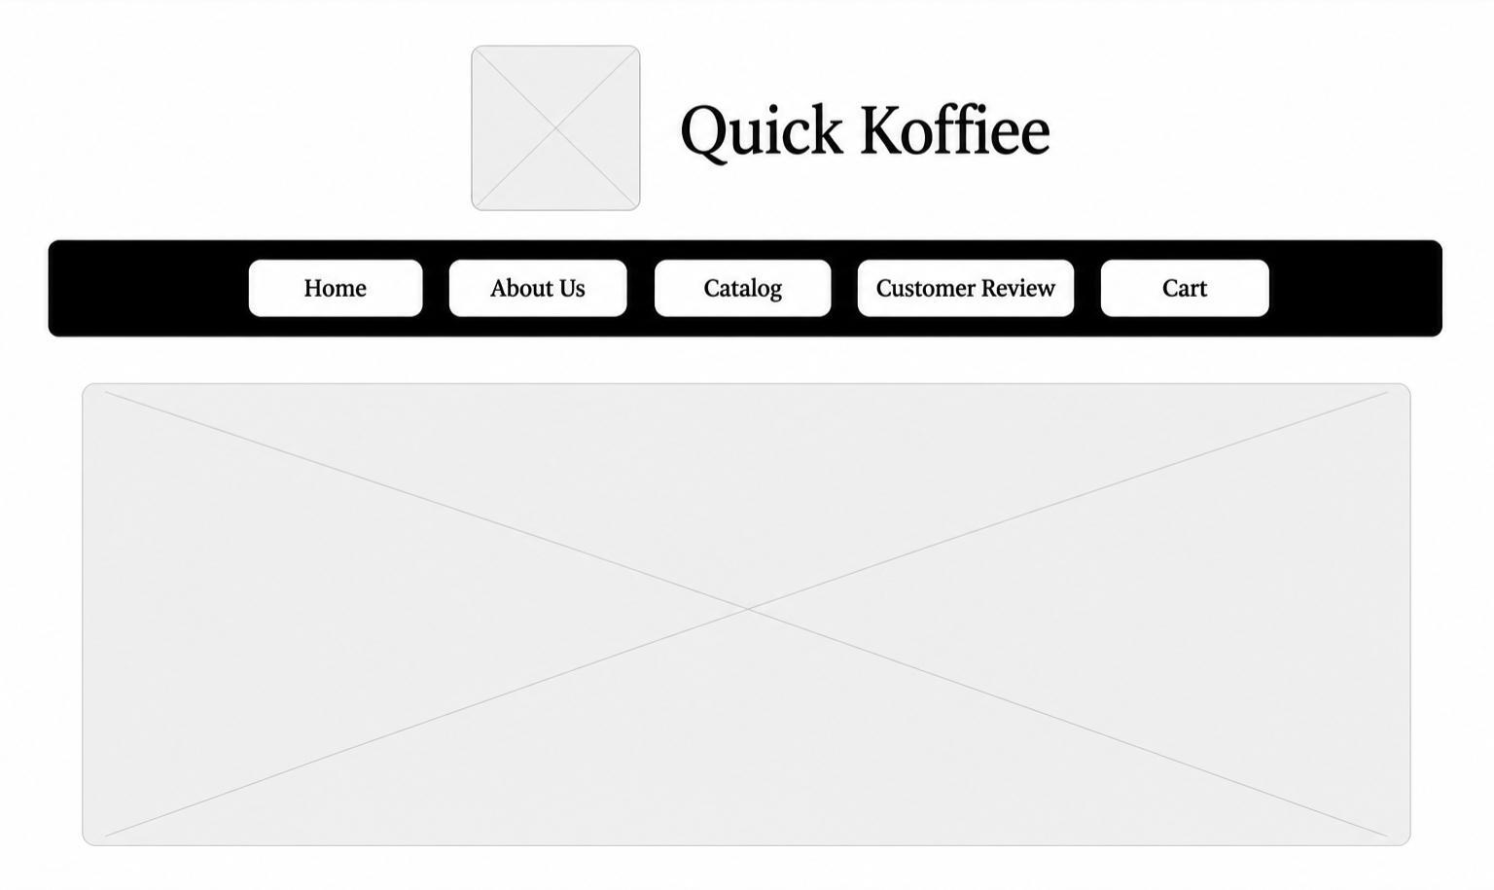
4. The Production Stack & Technical Choices
I hand-picked a modern, lightweight development stack to ensure complete control over every pixel, transition, and validation script:
- HTML5: The foundation. Semantic elements keep the layout robust, readable, and highly accessible.
- Custom CSS3 (style.css): Formulates the complete design system, handling corporate color mapping (dark brown #4a2c11, medium brown #784b36, light accent cream #e8c595), rounded pill border shapes, smooth hover
effects, and fluid flexible column wrapping logic.
- Bootstrap v5: Linked externally via content delivery networks (CDNs) to implement standardized typography grids, container alignment rules, and mobile utilities.
- Vanilla JavaScript (cart.js): The programming engine is decoupled into an external script sheet. It manages cross-page states by capturing user selection data, parsing and writing to the browser's browser storage utility (localStorage), and executing message encoding schemas.
- Version Control (GitHub & GitHub Pages): Used to track incremental commits, store assets, and handle open-source hosting directly out of the project repository.

